Online Small Groups with Saddleback’s Online Campus

- Provide a way for groups to access material digitally
a. Video based material through online access
b. Create email list for hosts and email weekly discussion questions based on weekend message

- Promote platform to meet
a. text – whatsapp, slack, or facebok group
b. audio – phone call, zoom.us, facetime, or skype
c. video – facetime, zoom.us, skype

Video resources:
- How to use Zoom.us for online groups https://youtu.be/7Lyex714UH8
- Favorite Online Group Platforms https://youtu.be/OHMWyTfb5fc
- Strategy
Encourage text groups to move to audio groups and audio groups to move to video and video groups to in person home groups. The goal is to have all online small groups over six months become home small groups.
Video resource:
- To understand the overall Online Campus community to commissioned process take church online course http://jaykranda.com/5-part-course-on-church-online
Helpful references
a. Overview of Online Campus small groups process
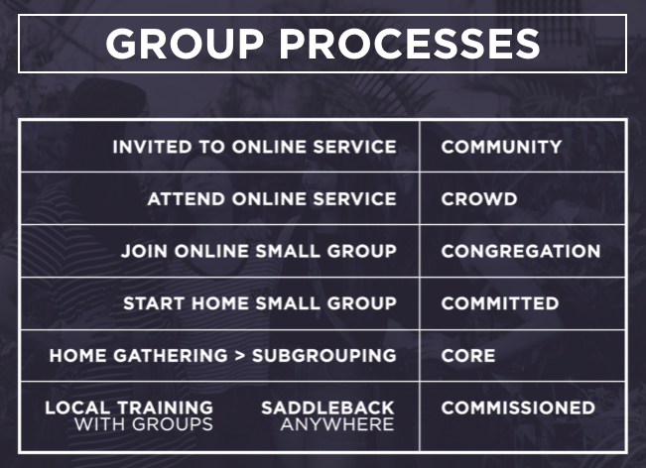
b. Overview of rounding the bases with Online Campus
